**ETHICAL HACKING**

**KALI LINUX BASIC COMMANDS**

**Date command-**

The **'date'** command is used to display the **system date** and **time.**



**Cd command-**

The **'cd'** command is also called **chdir** (Change Directory). We used this command to **change** or **switch** the current working directory.

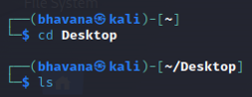

**Cp command-**

The **'cp'** command is used to **copy** files or a group of files or directories that create an exact image of a file

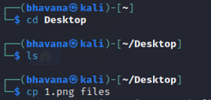

**Whoami command-**

The **'whoami'** command is used to print the effective **user ID** whereas the **who** command prints information regarding users who are presently logged in.

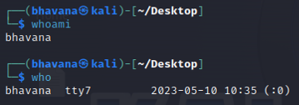

**Ls command-**

The **ls** command lists the directory contents of files and directories.

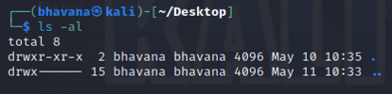

**Cat command-**

we use the cat command to display the content of a file.

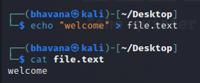

**Mkdir command-**

The **'mkdir'** command is used to **create directories.**

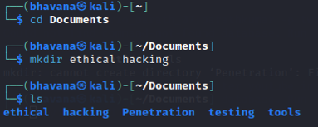

**Rm command-**

The **'rm'** command is used to **delete files.**

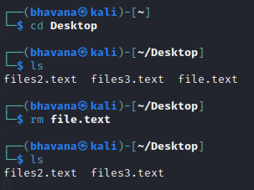

**Mv command-**

The **'mv'** command, we can **move** or **renames** files and directories on our file system.

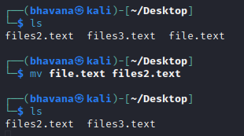

**Uname command-**

The **'uname'** command displays the **current system's information.**

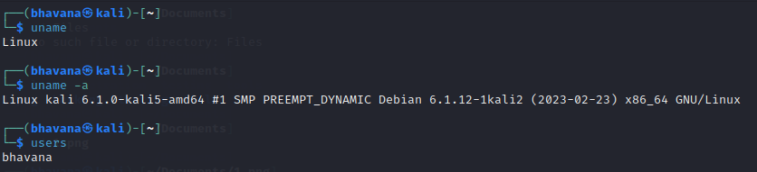

**Uptime command-**

The **'uptime'** command displays the amount of time the system has been running.

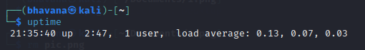

**Users command-**

The **'users'** command is used to display the **login names** of users logged in on the system.

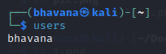

**Less command-**

The **'less'** command is used to view files instead of opening the file.

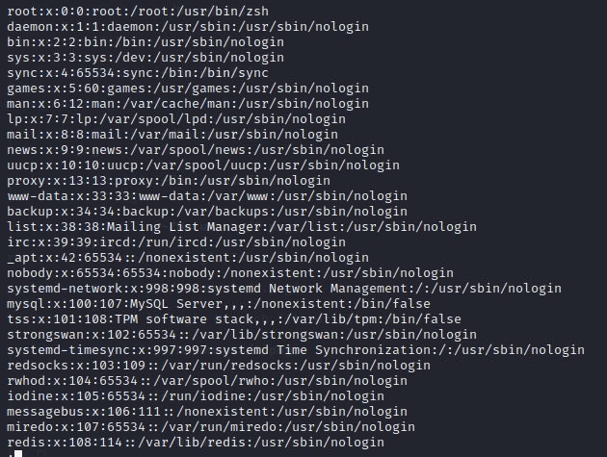

**More command-**

The **"more"** command permits us to show output in the terminal one page at a time.

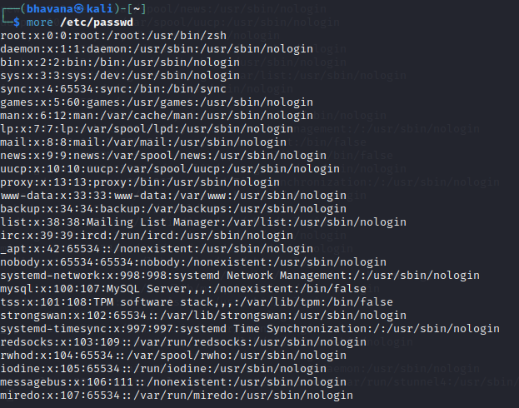

**Vi command-**

The **'vi'** editor is a screen editor that comes with practically every **UNIX** system. The **command mode** and the **insert mode** are the two most common nodes in vi.



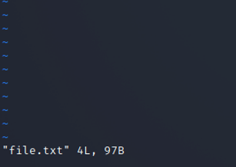

**Free command-**

The **'free'** command provides us the useful information about the **amount of RAM** available on a Linux machine

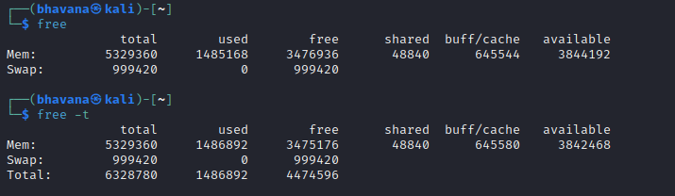

**History command-**

History command in the bash shell saves a history of commands entered that can be used to repeat commands.

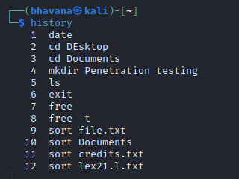

**Pwd command-**

The **'Pwd'** command is used to **print working directory.**

